Pete Steggall’s Plinths for Hire.
Hire Options.

 | Set 1 | Set 2 | Set 3
Options | Timber “Window” Design  Set of (15) | Conventional Cube Design  Set of (22) | Column with flat top design  Set of (28). (Includes stabilizing sandbags for smaller width columns).
 | 9 @ 300 x 300 x 850 High | 2@ 300 x 300 x 0.15 High | 1 @ 250 Dia x 2.3 High
 | 4 @ 400 x 300 x 850 High | 1@ 300 x 300 x 0.45 High | 3 @ 250 Dia x 1.1 High
 | 2 @ 600 x 300 x 850 High | 2@ 300 x 300 x 0.30 High | 6 @ 250 Dia x 0.950 High
 |  | 2@ 300 x 300 x 0.30 High | 1 @ 250 Dia x 0.750 High
 |  | 1@ 350 x 350 x 0.50 High | 2 @ 250 Dia x 0.700 High
 |  | 1@ 400 x 400 x 0.55 High | 1 @ 250 Dia x 0.680 High
 |  | 3 @ 400 x 400 x 0.820 High | 2 @ 250 Dia x 0.600 High
 |  | 2 @ 500 x 500 x 0.820 High
 |  | 1 @ 600 x 600 x 0.700 High | 2 @ 300 Dia x 0.810 High
 |  | 1 @ 650 x 650 x 0.800 High
 |  | 1 @ 400 x 400 x 0.600 High | 1 @ 320 Dia x 0.980 High
 |  | 4 @ 400 x 400 x 0.800 High | 2 @ 320 Dia x 1.00 High
 |  | 1 @ 400 x 400 x 0.900 High
 |  |  | 1 @ 400 Dia x 0.360 High
 |  |  | 1 @ 400 Dia x 0.450 High
 |  |  | 2 @ 400 Dia x 0.500 High
 |  |  | 2 @ 400 Dia x 0.600 High
 |  |  | 1 @ 400 Dia x 1.100 High
Price for complete set. Min 10 days (Friday – Monday. Including 2 weekends) | $400.00 | $300.00 | $350.00
Price for complete set. Multiple 10 days (Friday – Monday) | Per additional period  $300.00 | Per additional period  $250.00 | Per additional period  $350.00
Price for part of set. | negotiable | negotiable | negotiable
Security deposit for damage repairs if required. (Refundable if no damage) | $250.00 | $250.00 | $250.00
Re-colour to order. | No | yes | yes
Delivery available. Price pending location | yes | yes | yes
Set 4  Perspex Gold and Silver discs for tops, (Shows the bottoms of items) | no | no | Yes  $150/set/ 10-day period

*If a re-colour is chosen on Sets 2 or 3 which is different to the standard Gallery Grey or Polar White a charge for 1) re-colouring as required and 2) back to the original will be charged. (Includes labour and materials and reverse to original after your use).

Contact

Pete Steggall Phone 0420 366 138

Daniel Skeffington 0419 480 711

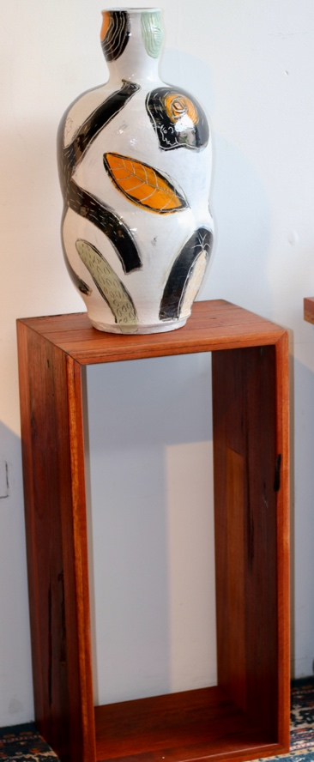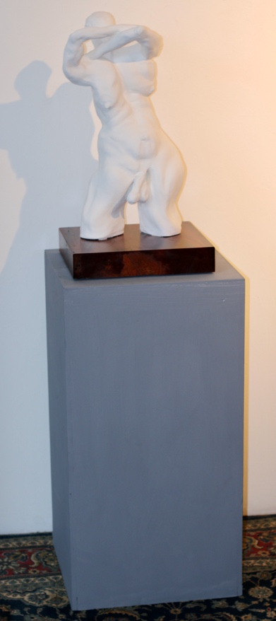
Set 2. Conventional Cube Design.
Set of (22)

Set 1. Timber “Window” Design.
Set of (15)

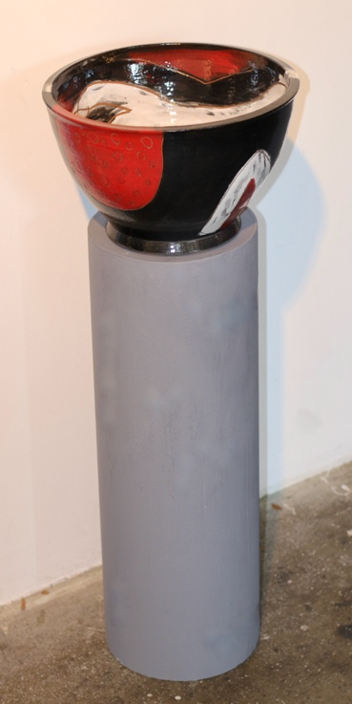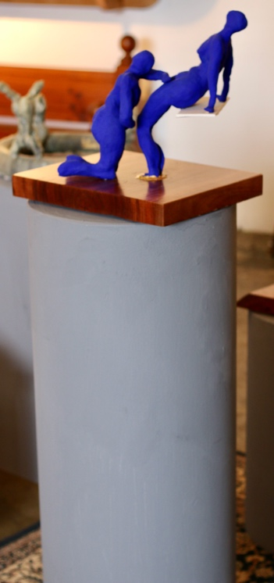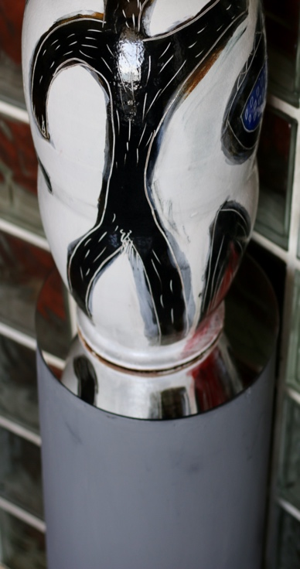

Set 3. Column with flat top design.
Set of (28)

Perspex Gold and Silver discs for tops of columns

